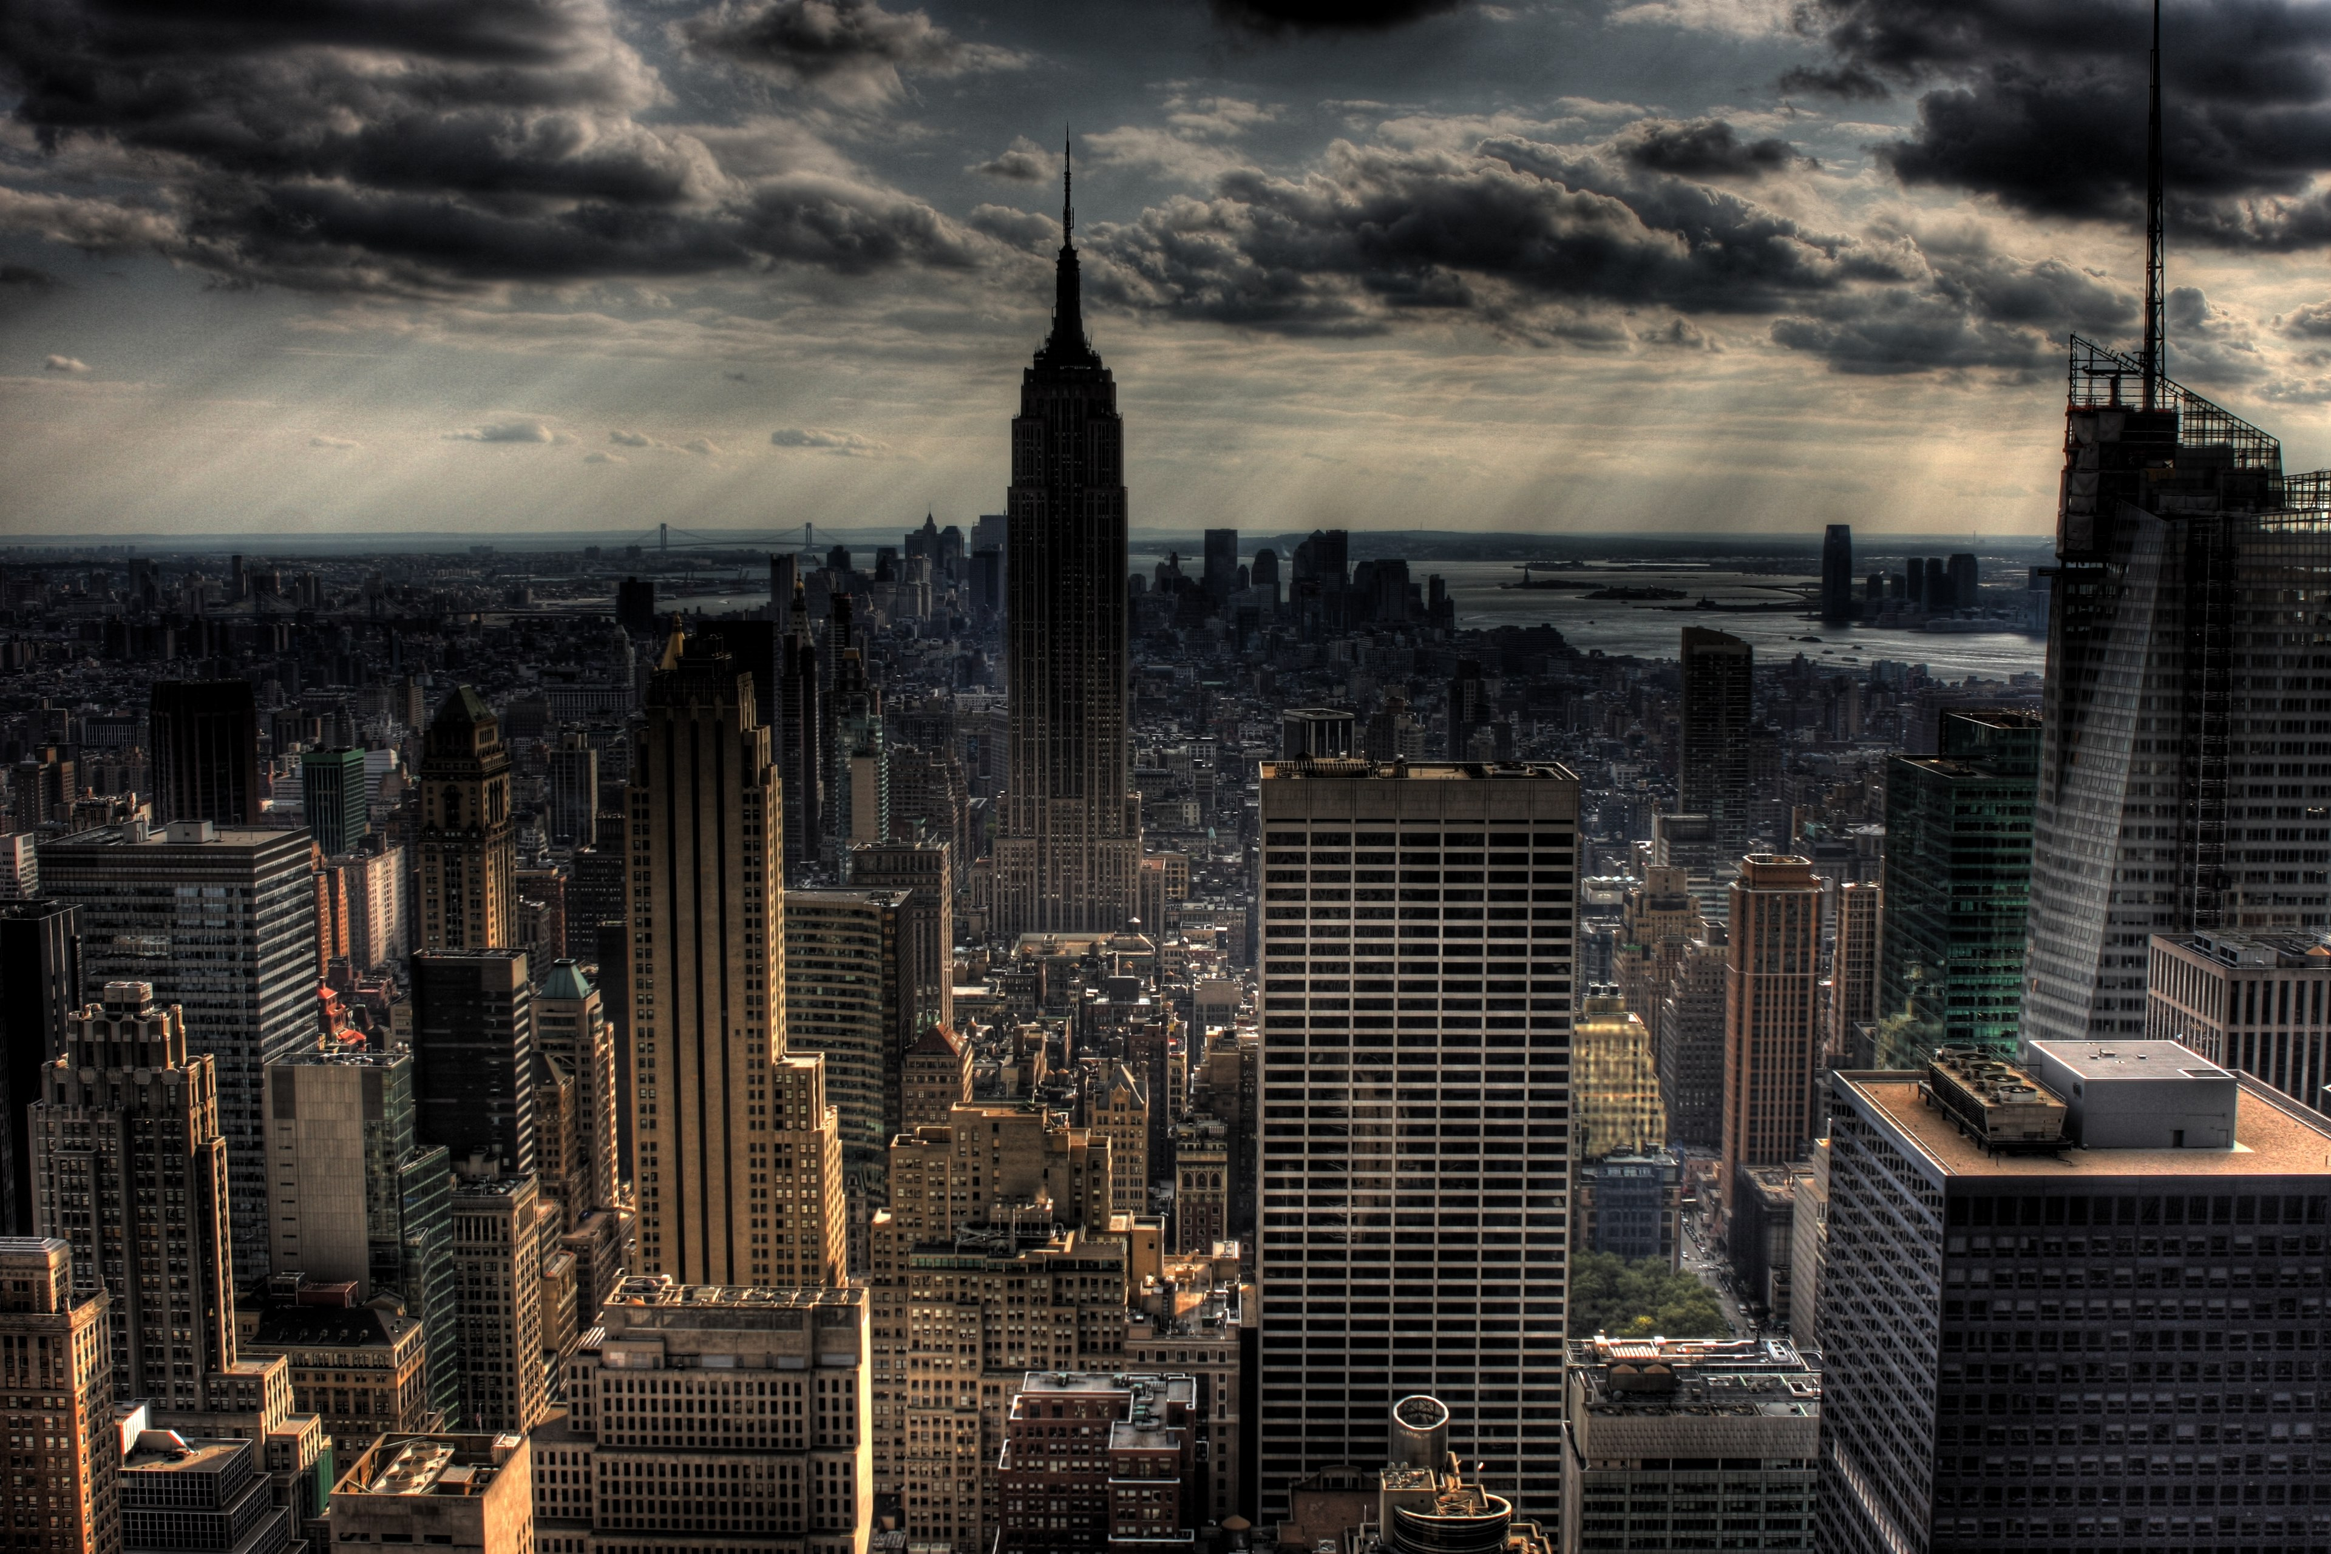

New York City Crime analysis

Team - The Dorm Room Developers

* Abhishek Kuntal
* Nanda Kishore Kalidindi
* Saurav Mawandia

**Contents**

**1.** **Project Overview** 3

**2.** **Crime Dataset** 4

**3.** **Visualizing crime data** 6

3.1 Crimes week visualization for the Week of June 12, 2016 6

3.2 Crimes in NYC 6

3.3 Per Hour Average Crime count 7

3.4 Month Vs Crime 7

3.4 Crime at hour of day, season of the year 8

**4.** **Correlation of Crime with weather** 9

4.1 Crime Count vs Temperature in Degree Celsius 10

4.2 Number of Crimes Vs Temperature vs Hour of the Day 12

**5.** **Correlation of Crime with population and Median Income** 13

5.1 Crime in different areas of NYC 13

5.2 Median Income in different areas of NYC 13

5.3 Population in different areas of NYC 14

5.4 Mean Income Vs Crime 14

**6.** **Correlation of Crime with Markets** 15

6.1 Decrease in Crime with Increase in Dow Jones Index 15

6.2 Impact of 2008 recession on crime 15

**7.** **Recommendation based on Crime** 16

7.1 Hotels in NYC 16

7.2 Bars in NYC 17

**8.** **Technology Used** 19

**9.** **Conclusion** 20

1. Project Overview

With the number of crime incidents increasing daily, we thought of analyzing NYC crime data and find out whether the below factors have any influence on perpetrator

* Weather (Gathered last 10 years data from Open data)

Data Source: <http://w2.weather.gov/climate/index.php?wfo=okx>

* Stock Market

Data Source: <http://www.macrotrends.net/1358/dow-jones-industrial-average-last-10-years>

* Mean Household Income (Collected last 10 years of population in NYC on various zip code and there median and mean Income)

Data Source: <https://www.psc.isr.umich.edu/dis/census/Features/tract2zip/>

We also took this opportunity to find number of crime incidents near frequently visited places

* Compiled the list of safe and unsafe hotels in New York city

Data Source: Trip Advisor <http://times.cs.uiuc.edu/~wang296/Data/LARA/TripAdvisor/TripAdvisorJson.tar.bz2>

* Compiled the list of safe and unsafe Bars in New York city

Data Source: <https://data.ny.gov/Economic-Development/Liquor-Authority-Quarterly-List-of-Active-Licenses/hrvs-fxs2/data>

1. **Crime Dataset**

The Crime [dataset](https://catalog.data.gov/dataset/nypd-complaint-data-current-ytd) has 24 columns as shown below.

CMPLNT_NUM CMPLNT_FR_DT CMPLNT_FR_TM CMPLNT_TO_DT CMPLNT_TO_TM RPT_DT KY_CD OFNS_DESC PD_CD PD_DESC CRM_ATPT_CPTD_CD LAW_CAT_CD JURIS_DESC BORO_NM ADDR_PCT_CD LOC_OF_OCCUR_DESC PREM_TYP_DESC PARKS_NM HADEVELOPT X_COORD_CD Y_COORD_CD Latitude Longitude Lat_Lon

We started by analyzing importance of each field. As, we did not find good metadata for the data.

* After analyzing the data, we found out there are three major types of crime

Code: crime_df.select("LAW_CAT_CD").distinct().show()

Results: Felony, Misdemeanor, Violation

* We also saw how many unique OFNS_Description are there in dataset

Code: crime_df.select("OFNS_DESC").distinct().count()

Result: We found out 71 unique description.

* We wanted to plot data in map based on zip code, but zip code was not present in dataset. So, we extracted zip code from latitude and longitude using google reverse geocoding API. This was the most challenging part of the project. As we ran out of limitation on calling the API and we had to gather the data for almost a week to get complete data (P.S we upgraded our google account to premium account to get the data)



Figure 1 Code Snippet to get zipcode form Lat,Lon

We then visualized the crime data we had and gathered some meaningful insights from it. We also normalized the date and time to visualize data as shown below.



1. **Visualizing crime data**

## Crimes week visualization for the Week of June 12, 2016

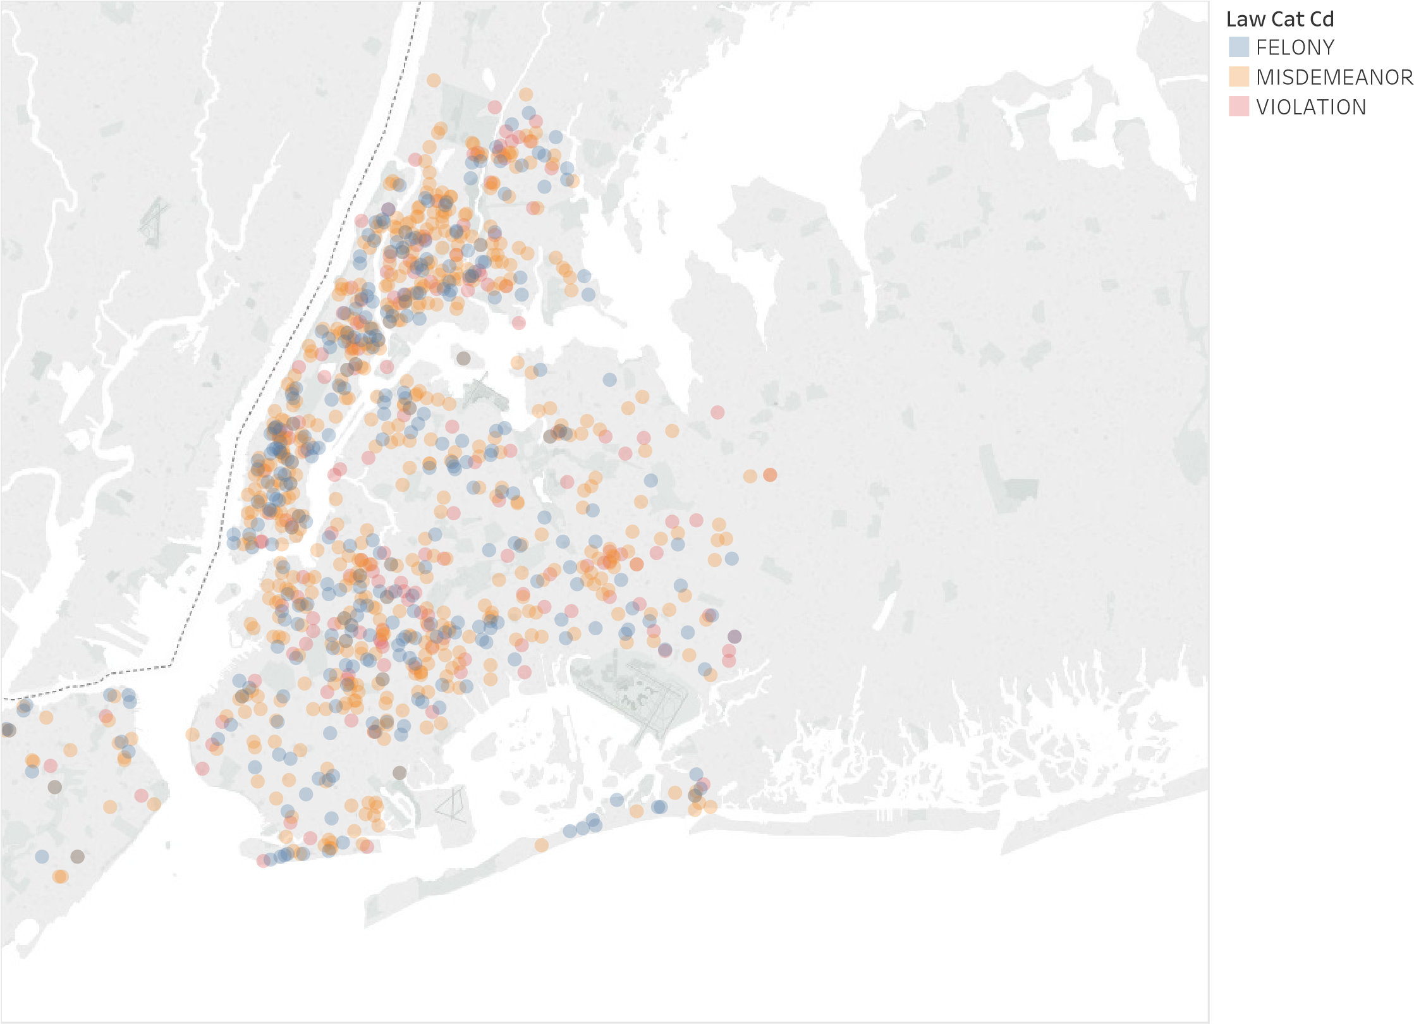

Map based on Longitude and Latitude. Color shows details about Law Cat Cd.

We visualized the three-different type of crime on map for the week of June 12, 2016 and tried understanding what are the locations which has most number of Incidents

## 3.2 Crimes in NYC

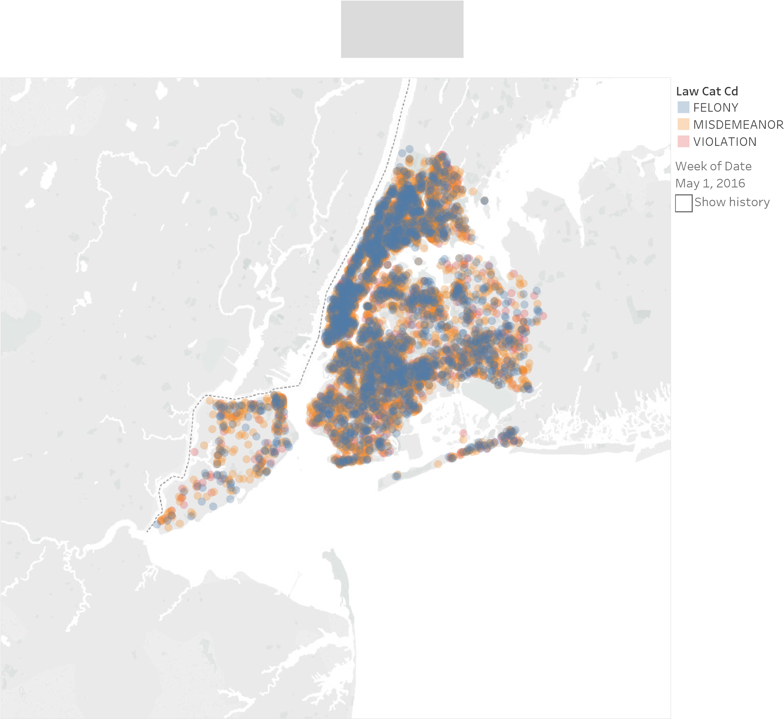

Figure 2 Crime in NYC for Last 10 years

We also tried to see that over a period of time which type of crime occurs at a particular location

## 3.3 Per Hour Average Crime count

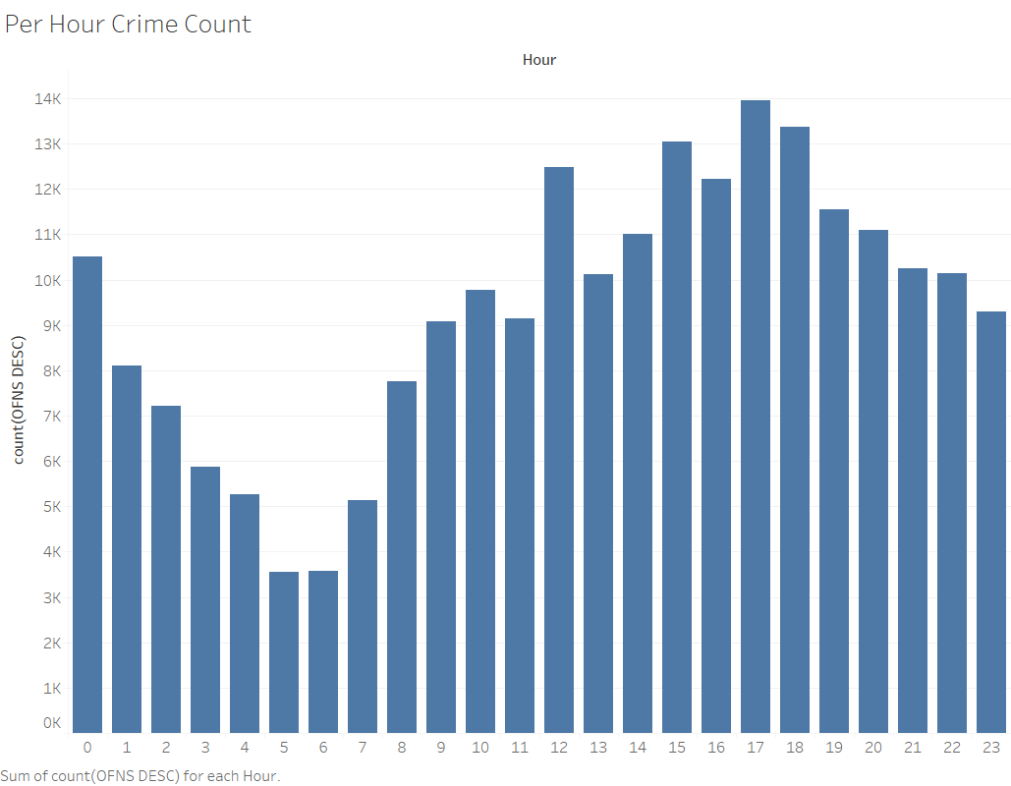

Figure 3 Average Crime Count every hour

We then tried to see that hour in the day has any co-relation with crime. The finding was interesting, we saw that crime was maximum around 06:00’clock in the evening when people return to their home.

## Month Vs Crime

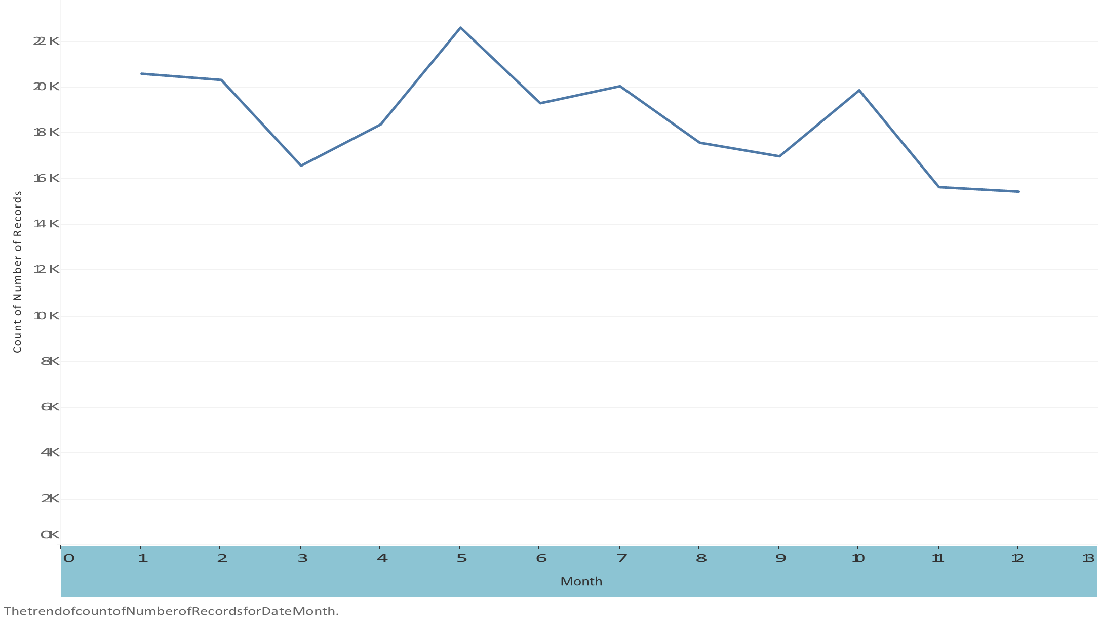

Figure 4 Month and Crime

We then tried to see if crime depends on the month of the year. It was interesting to see that the crime drastically dropped in month of December. This correlation was difficult to digest as the tourist come in this part of the year. May be the chilly weather stops the perpetuator.

## Crime at hour of day, season of the year

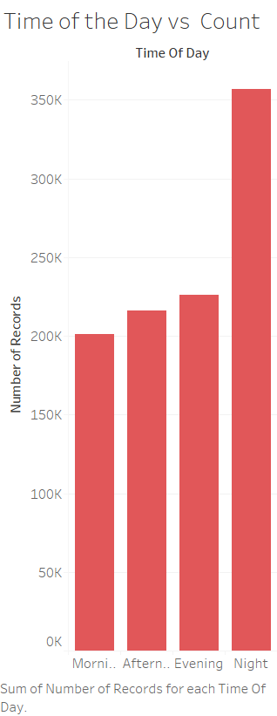 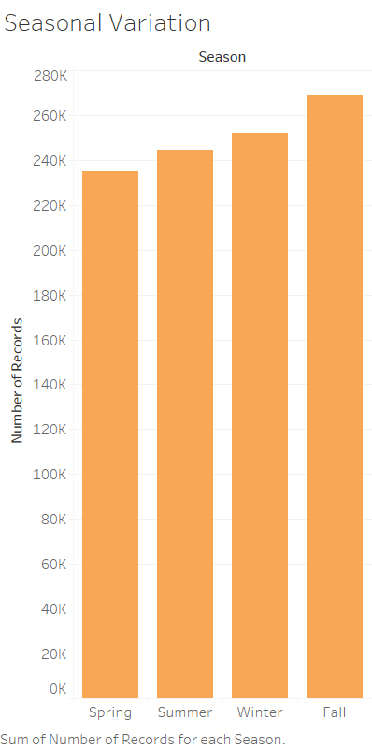

We then plotted the graph to see if time of day or season has impact on crime. The results where as expected, the crime was more at Night time and was lowest in morning.

The crime was also highest in fall, which was interesting correlation.

1. **Correlation of Crime with weather**

We then gathered weathered data for NYC and imported it in spark. We got hourly weather data for last 10 years and it had 90 columns as shown below.

'STATION', 'STATION_NAME', 'ELEVATION', 'LATITUDE', 'LONGITUDE', 'DATE', 'REPORTTPYE', 'HOURLYSKYCONDITIONS', 'HOURLYVISIBILITY', 'HOURLYPRSENTWEATHERTYPE', 'HOURLYDRYBULBTEMPF', 'HOURLYDRYBULBTEMPC', 'HOURLYWETBULBTEMPF', 'HOURLYWETBULBTEMPC', 'HOURLYDewPointTempF', 'HOURLYDewPointTempC', 'HOURLYRelativeHumidity', 'HOURLYWindSpeed', 'HOURLYWindDirection', 'HOURLYWindGustSpeed', 'HOURLYStationPressure', 'HOURLYPressureTendency', 'HOURLYPressureChange', 'HOURLYSeaLevelPressure', 'HOURLYPrecip', 'HOURLYAltimeterSetting', 'DAILYMaximumDryBulbTemp', 'DAILYMinimumDryBulbTemp', 'DAILYAverageDryBulbTemp', 'DAILYDeptFromNormalAverageTemp', 'DAILYAverageRelativeHumidity', 'DAILYAverageDewPointTemp', 'DAILYAverageWetBulbTemp', 'DAILYHeatingDegreeDays', 'DAILYCoolingDegreeDays', 'DAILYSunrise', 'DAILYSunset', 'DAILYWeather', 'DAILYPrecip', 'DAILYSnowfall', 'DAILYSnowDepth', 'DAILYAverageStationPressure', 'DAILYAverageSeaLevelPressure', 'DAILYAverageWindSpeed', 'DAILYPeakWindSpeed', 'PeakWindDirection', 'DAILYSustainedWindSpeed', 'DAILYSustainedWindDirection', 'MonthlyMaximumTemp', 'MonthlyMinimumTemp', 'MonthlyMeanTemp', 'MonthlyAverageRH', 'MonthlyDewpointTemp', 'MonthlyWetBulbTemp', 'MonthlyAvgHeatingDegreeDays', 'MonthlyAvgCoolingDegreeDays', 'MonthlyStationPressure', 'MonthlySeaLevelPressure', 'MonthlyAverageWindSpeed', 'MonthlyTotalSnowfall', 'MonthlyDeptFromNormalMaximumTemp', 'MonthlyDeptFromNormalMinimumTemp', 'MonthlyDeptFromNormalAverageTemp', 'MonthlyDeptFromNormalPrecip', 'MonthlyTotalLiquidPrecip', 'MonthlyGreatestPrecip', 'MonthlyGreatestPrecipDate', 'MonthlyGreatestSnowfall', 'MonthlyGreatestSnowfallDate', 'MonthlyGreatestSnowDepth', 'MonthlyGreatestSnowDepthDate', 'MonthlyDaysWithGT90Temp', 'MonthlyDaysWithLT32Temp', 'MonthlyDaysWithGT32Temp', 'MonthlyDaysWithLT0Temp', 'MonthlyDaysWithGT001Precip', 'MonthlyDaysWithGT010Precip', 'MonthlyDaysWithGT1Snow', 'MonthlyMaxSeaLevelPressureValue', 'MonthlyMaxSeaLevelPressureDate', 'MonthlyMaxSeaLevelPressureTime', 'MonthlyMinSeaLevelPressureValue', 'MonthlyMinSeaLevelPressureDate', 'MonthlyMinSeaLevelPressureTime', 'MonthlyTotalHeatingDegreeDays', 'MonthlyTotalCoolingDegreeDays', 'MonthlyDeptFromNormalHeatingDD', 'MonthlyDeptFromNormalCoolingDD', 'MonthlyTotalSeasonToDateHeatingDD', 'MonthlyTotalSeasonToDateCoolingDD

We were perplexed by the temperature value in this column and then finally decided to go with HourlyBulbTemperature to co-relate with crime. We normalized the dates and then cleaned the dataset,

Finally, we merged the crime and weather data set based on hour and day and gathered some insights as discussed below.

## Crime Count vs Temperature in Degree Celsius

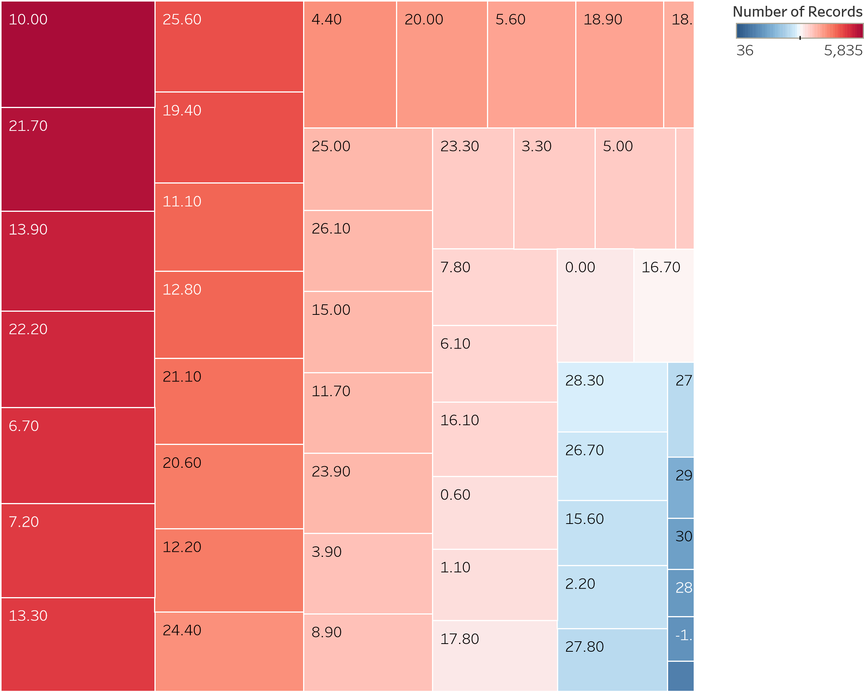

Figure 5 Temperature and Crime count

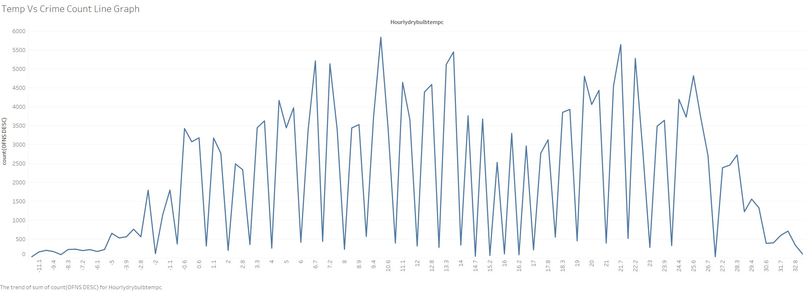

Figure 6 Temperature and Crime count for 2016

We started plotting crime count based on temperature and saw the crime was highest at 10 degrees and lowest at -1. This correlation was kind of expected, as we expect perpetrator to commit less crime on a very chilly day.

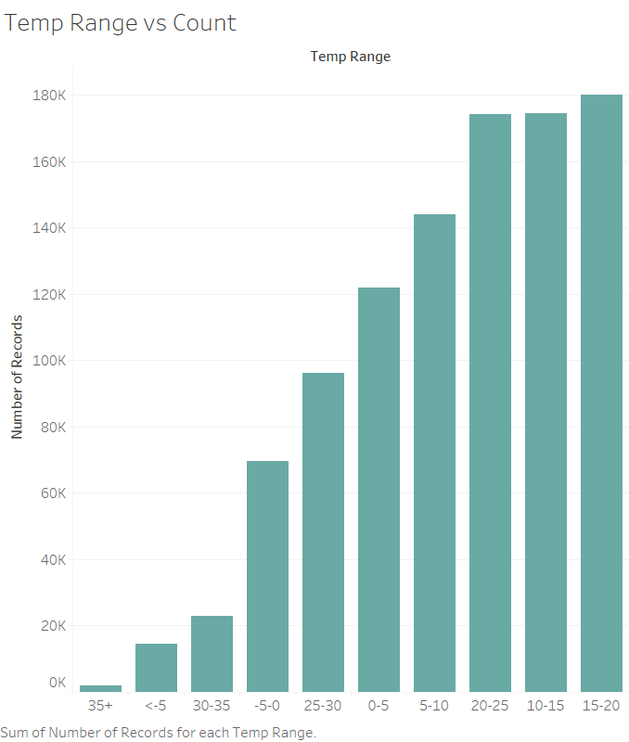

Figure 7 Range of Temperature and Crime

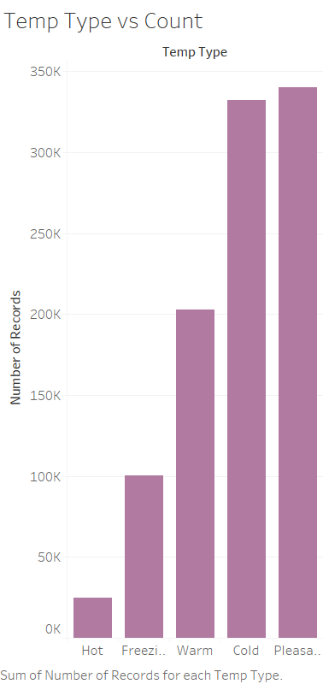

Figure 8 Temperature type and Crime

We visualized the crime was maximum in pleasant temperature and was minimum In hot temperature.

## Number of Crimes Vs Temperature vs Hour of the Day

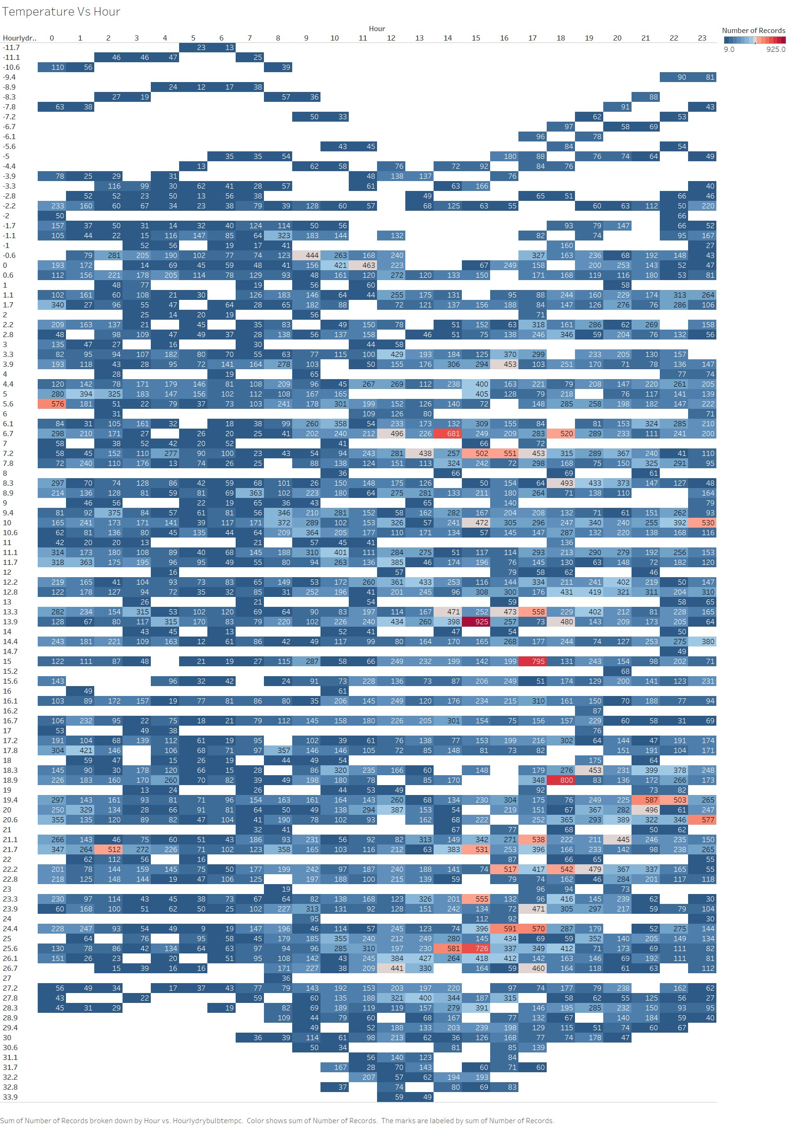

We then plotted a graph from temperature and time of the day to see what is the most favorable condition and find out that if it is 03:00pm and it is 20 degrees Celsius the chances of you being a victim are very high. Which was an interesting finding.

1. **Correlation of Crime with population and Median Income**

We also download the population and median income dataset and cleaned it. We then merged the census data based on zip code and started analyzing crime based on population and wealth.

## 5.1 Crime in different areas of NYC

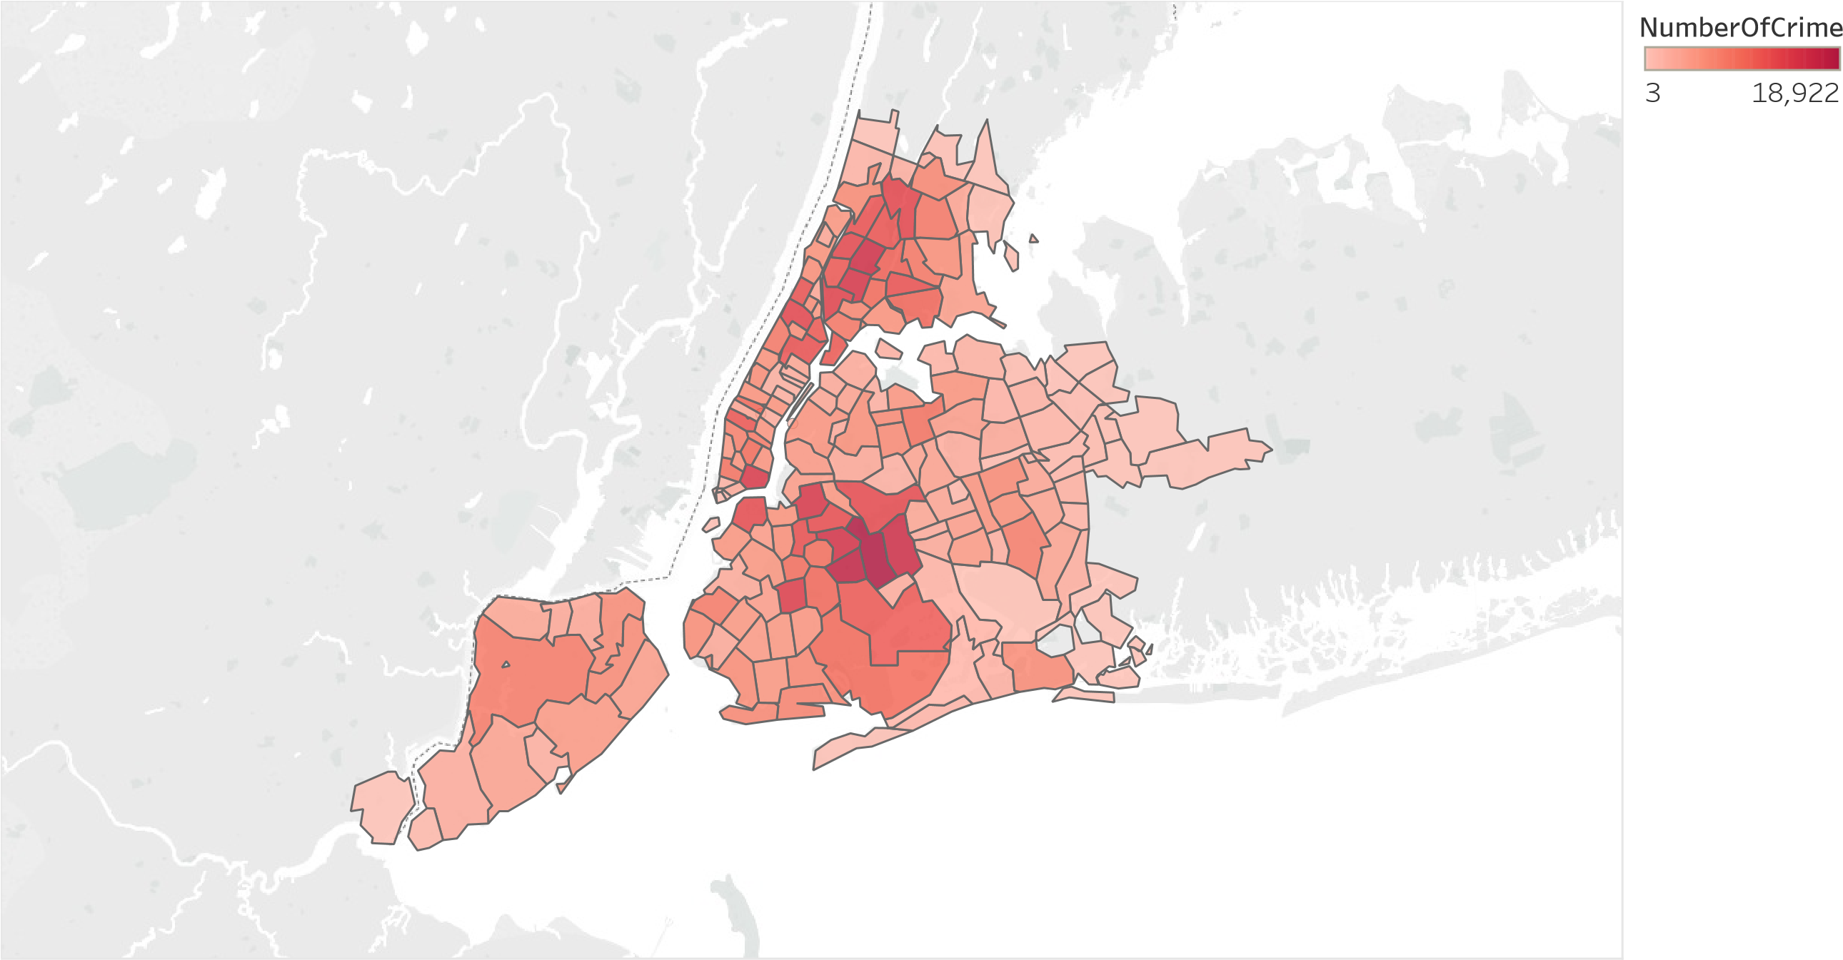

Figure 9 Map based on Longitude (generated) and Latitude (generated). Color shows sum of NumberOfCrime. Details are shown for Zipcode.

We visualized that crime was more in some parts of Queens and Upper Manhattan. We were interested to see what is the population in that part and what is the median income there.

## 5.2 Median Income in different areas of NYC

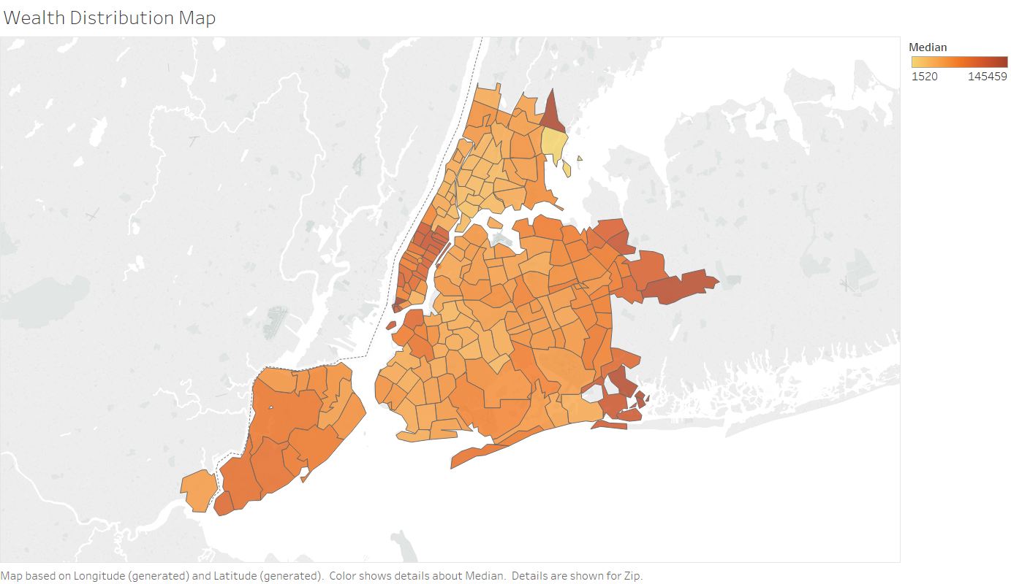

The results showed that where the crime was more the income was less. This was kind of expexted.

## 5.3 Population in different areas of NYC

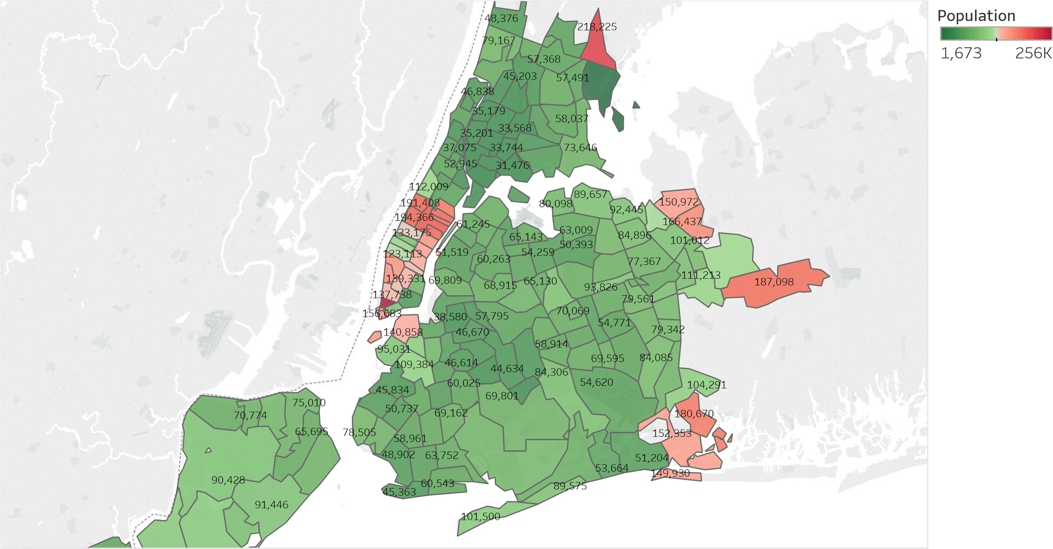

Figure 10 Map based on Longitude (generated) and Latitude (generated). Color shows sum of Population. The marks are labeled by sum of Population. Details are shown for Zipcode.

The population had a minor impact on crime. The conclusion we derived was that with low population the crime gradually increases which can be seen from the above map.

## 5.4 Mean Income Vs Crime

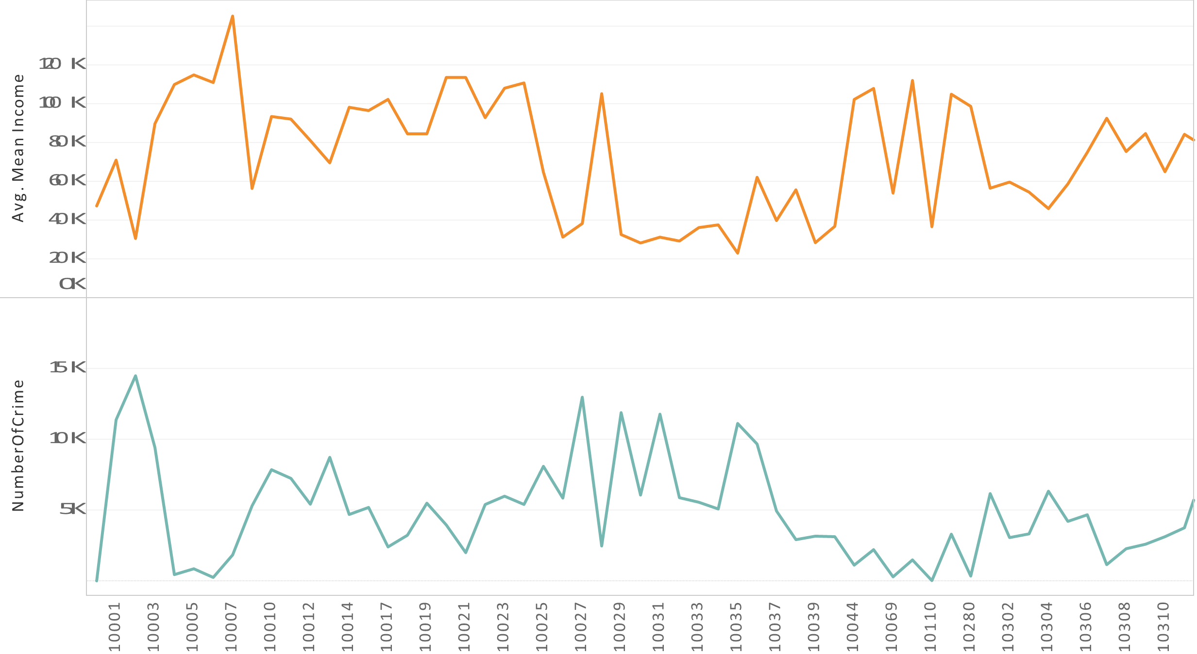

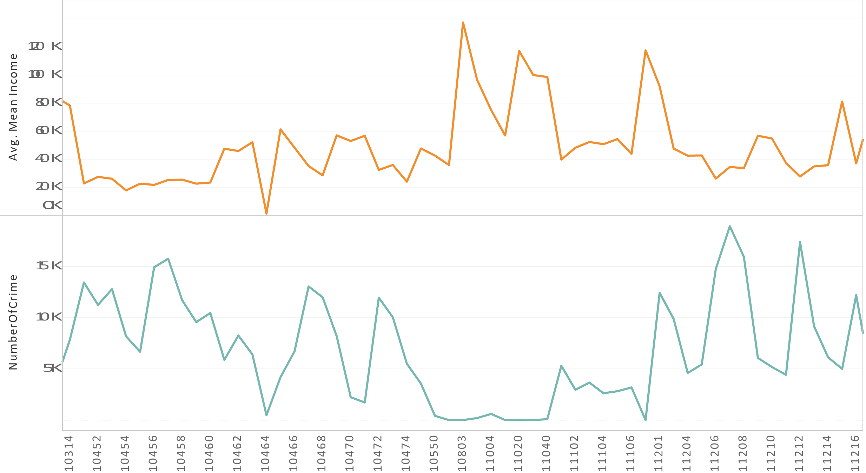

We then plotted graph to visualize the crime count and median income. Crime is clearly inversely proportional to income

1. **Correlation of Crime with Markets**

We then downloaded the stock market data for last 10 years. We then cleaned the dataset and normalized the date of the data and merged ii with crime data.

## 6.1 Decrease in Crime with Increase in Dow Jones Index

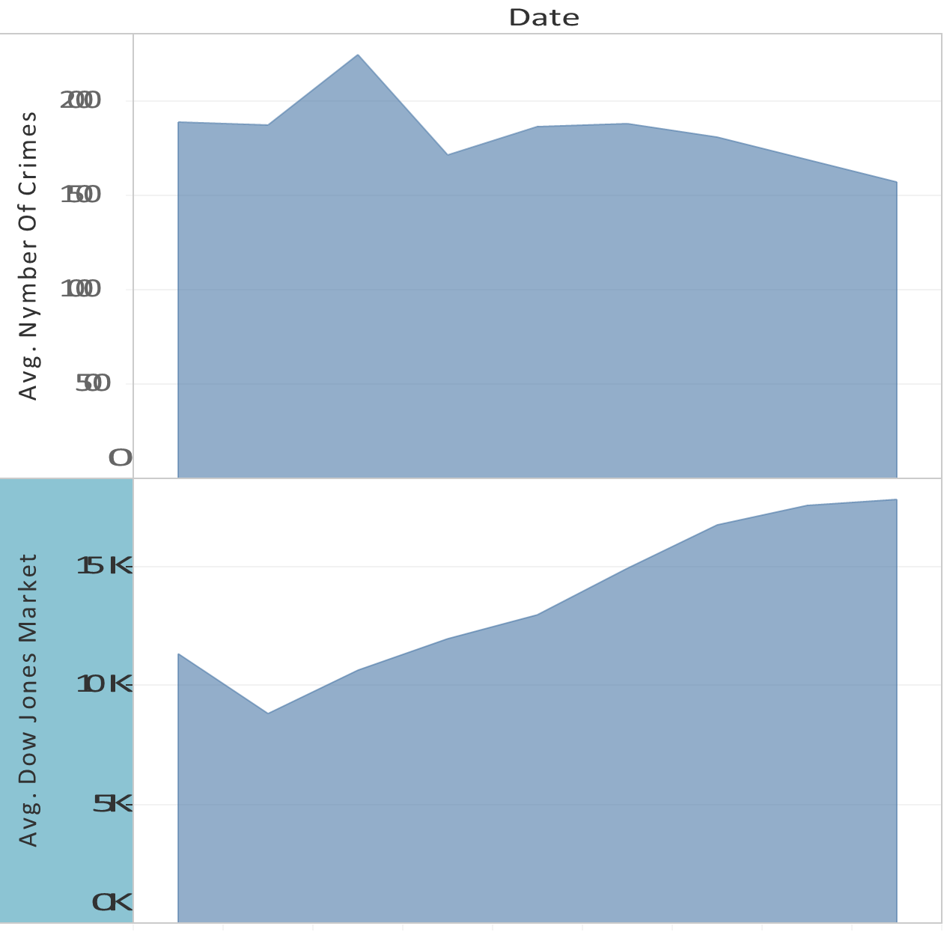

Figure 11 Average of Count and average of Value for each Date Year.

We saw that as the Dow zone index increased the crime has decreased. But this can be a coincidence as well, It is a possibility that crime has decreased over year due to strict law enforcement.

## 6.2 Impact of 2008 recession on crime

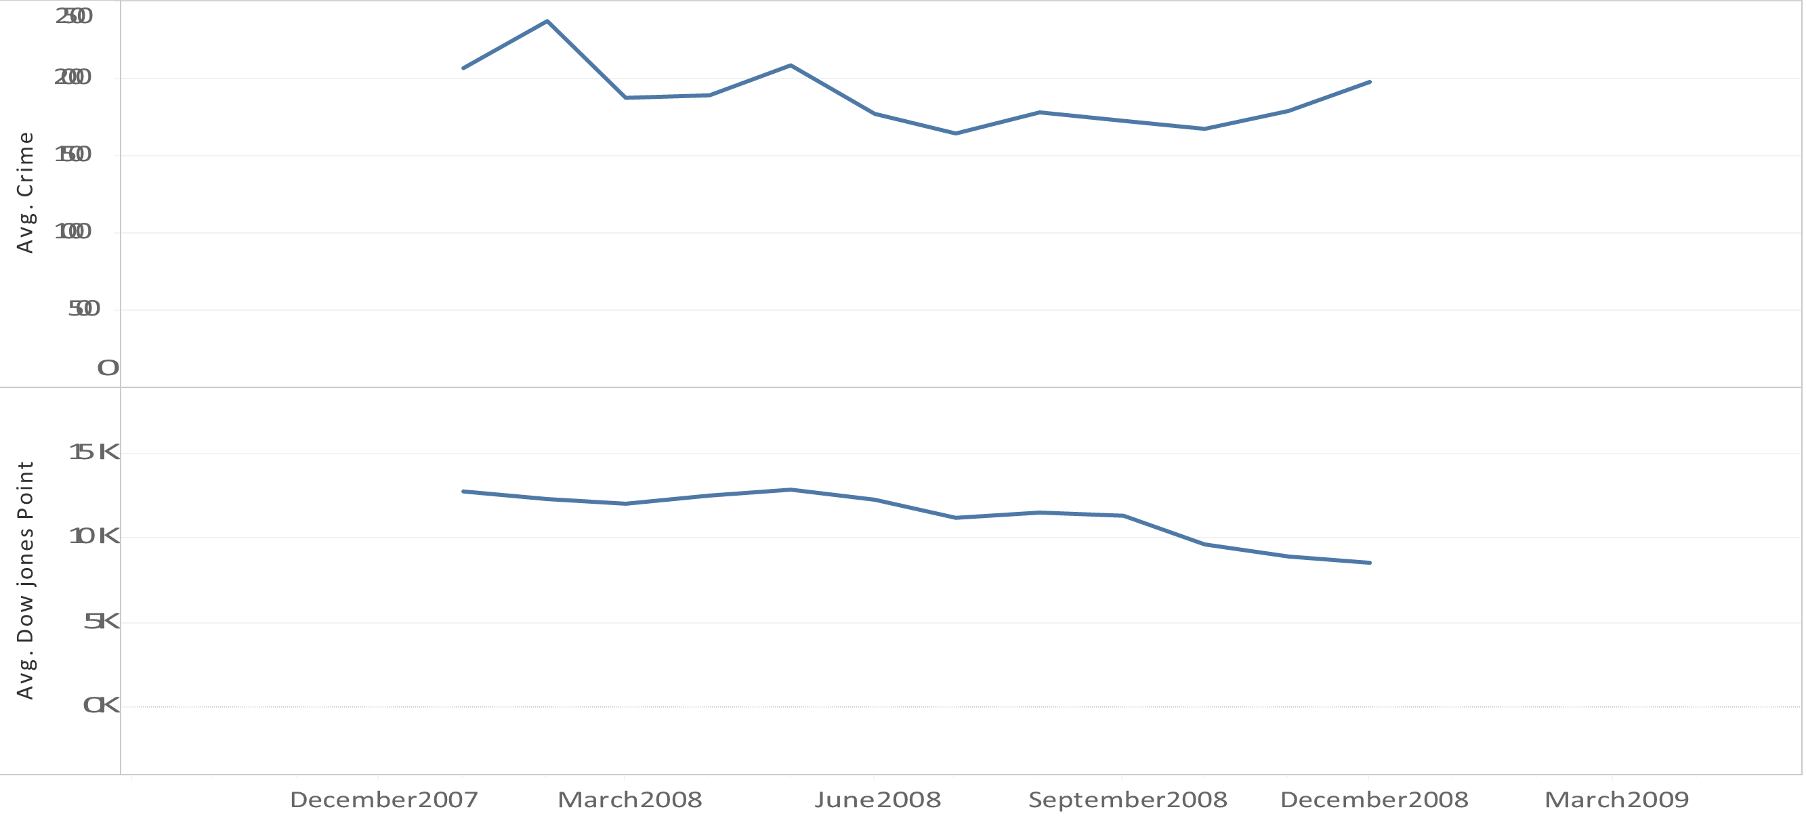

Figure 12 The trends of average of Count and average of Value for Date Month. The data is filtered on Date Year, which keeps 2008.

We then wondered that when the market crashed in 2008 did it impact crime? The answer to this is visible in the graph above. We can clearly see that there was an increase in crime when the market crashed. So, there is for sure some correlation between stock market and crime.

1. **Recommendation based on Crime**

When a person travels to a new city his biggest concern is wherever he is booking the hotel, the area should be safe. We downloaded the trip advisor dataset and filtered hotels of New York and then extracted zip code of each hotel and merged the hotel dataset with crime dataset based on zip code. We then visualized few hotels and crime near them.

## 7.1 Hotels in NYC

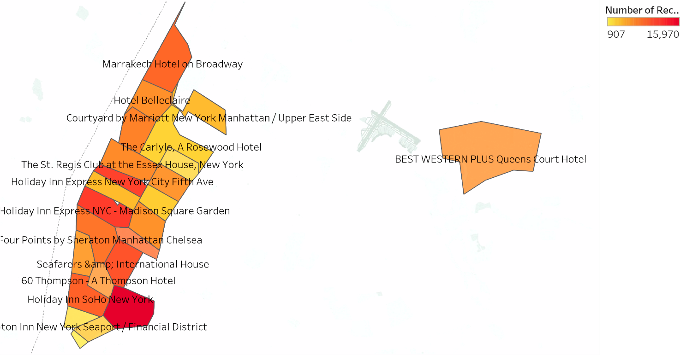

Figure 13 Map based on Longitude (generated) and Latitude (generated).

The above map gives some valuable insights about the hotels one should book based on location.

We also came up with top 10 and bottom 10 hotels based on location

|  |  |
| --- | --- |
| Hotel Name | Number of reported Incidents near them |
| Club Quarters Downtown | 1981 |
| Millenium Hilton | 4004 |
| 254 East Vacation | 4636 |
| Loews Regency Hotel | 4636 |
| The Carlyle, A Rosewood Hotel | 4636 |
| The Helmsley Carlton House | 4636 |
| The Bentley Hotel | 5018 |
| Dylan Hotel | 5372 |
| Helmsley Middletowne Hotel | 5372 |
| Hilton Manhattan East | 5372 |
| New York Marriott East Side | 5372 |
| Roger Smith Hotel | 5372 |
| The Alex Hotel | 5372 |
| The New York Helmsley | 5372 |
| The Roosevelt Hotel | 5372 |
| Safe hotels in NYC |

|  |  |
| --- | --- |
| Hotels | Number of Incidents Near them |
| Chelsea Star Hotel | 24539 |
| Comfort Inn Manhattan | 24539 |
| Herald Square Hotel | 24539 |
| Holiday Inn Express NYC - Madison Square Garden | 24539 |
| Hotel Pennsylvania New York | 24539 |
| Hotel Stanford | 24539 |
| La Quinta Inn Manhattan | 24539 |
| Radisson Martinique on Broadway | 24539 |
| Wingate by Wyndham Manhattan Midtown | 24539 |
| nyma, the New York Manhattan Hotel | 24539 |
| Hotel on Rivington | 33605 |
| Off Soho Suites | 33605 |
| Windsor Hotel | 33605 |
| Not so Safe hotels in NYC |  |

## 7.2 Bars in NYC

We then downloaded the bar license dataset, cleaned it and merged it with crime data set to come out with list of safe and not so safe bars.

|  |  |
| --- | --- |
| Bars | Crime Count |
| 111 AGAM CORPORATION, 10704 | 1 |
| 1132 CONVENIENCE CORP, 10704 | 1 |
| 1160 YONKERS AVE FOOD CORP, 10704 | 1 |
| 115 WOLFS LANE RESTAURANT CORP, 10803 | 6 |
| 2016 NEW HOPE GROCERY CORP, 10705 | 19 |
| 2020 YONKERS DELI GROCERY CORP, 10705 | 19 |
| 208 SARATOGA FOOD CORP, 10705 | 19 |
| 108 COVERT AVENUE PUB INC, 11530 | 93 |
| 2048 HILLSIDE RESTAURANT CORP, 11040 | 188 |
| 205 SERVICE STATION INC, 11040 | 188 |
| 2201 GAS CORP, 11040 | 188 |
| Safe bars in NYC |  |

|  |  |
| --- | --- |
| Bars | Crime Count |
| 230 JC DELI GROCERY INC, 10457 | 36327 |
| 1155 NEW WAY DELI CORP, 11208 | 36558 |
| 1176 LIBERTY FOOD CORP, 11208 | 36558 |
| 1290 SUTTER GROCERY INC, 11208 | 36558 |
| 160 CRESCENT DELI &amp; GROCERY CORP, 11208 | 36558 |
| 208 CRESCENT MEAT &amp; PRODUCE INC, 11208 | 36558 |
| 2552 DELI CORP, 11208 | 36558 |
| 255 E 95 ST FOOD CORP, 11212 | 38172 |
| 1115 PENNSYLVANIA MEAT CORP, 11207 | 42442 |
| 200 JAMAICA FOOD CORP, 11207 | 42442 |
| 2053 PITKIN MINIMARKET INC, 11207 | 42442 |
| 106 AMSTERDAM REST CORP, 10029 | 55808 |

Not so safe bars in NYC

1. **Technology Used**

* Apache Zeppelin
* Apache Spark
* Scala
* Python
* Tableau
* Databricks cloud platform
* Google Reverse geocoding API

1. **Conclusion**

As we write this report there is a crime happening somewhere in NYC. The crimes in New York is mundane. This project gave us a good insight on how crime occurs in different areas of NYC. These insights can be used to control the crime. We have good insights how crime varies in month and the location which are impacted the most. If these insights are considered by NYPD we can work together for a better New York. Crime rate in a locality can become one factor for people to decide which hotel to stay or which bars to visit.